Nutricare Documentation-Calculations

Add Dish Details:

Add New Ingredients - Calculations:

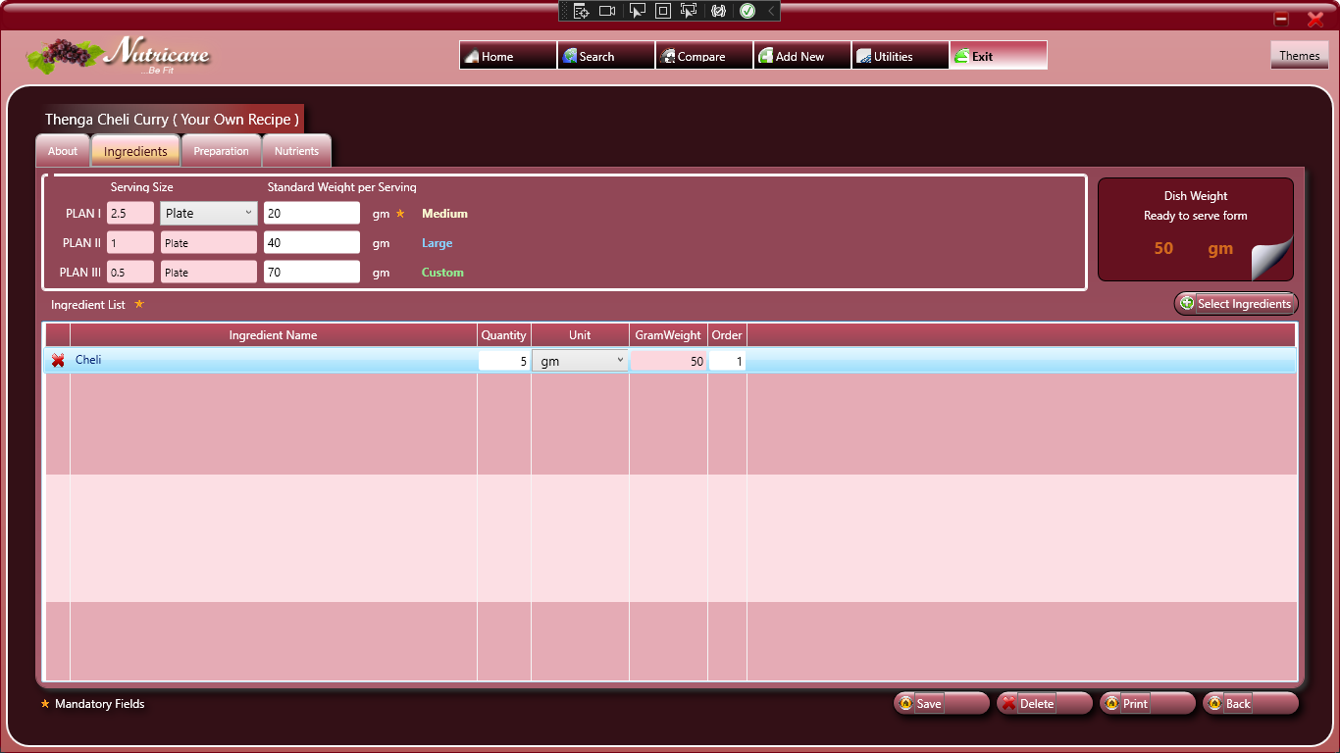 [Calculate Standard Weight = Quantity * Standard Unit(Ingredient Standard Unit)]

Nutrient Value Listing - Calculation:

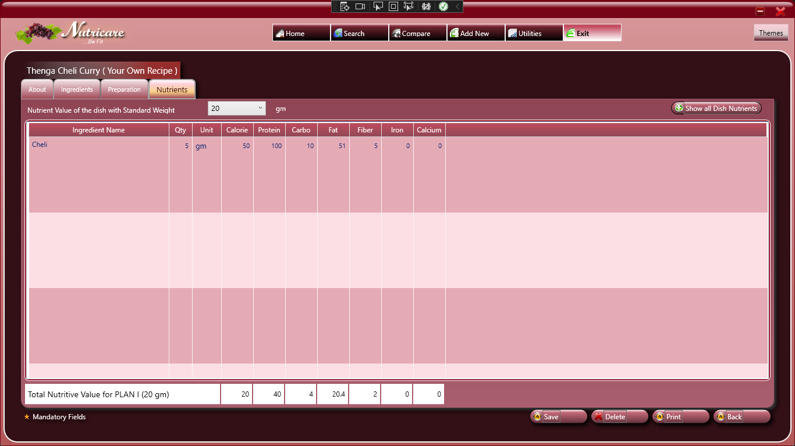

NutrientValue_Sum = NutrientValue_Sum + NutrientValue[0]

For Every Change in Standard Weight;-

ServingSize = ServingSize * ServingWeight

Total NutrientValue =( NutrientValue_Sum / ServingSize ) * Standard Weight

Show Dish by Dish_id ;

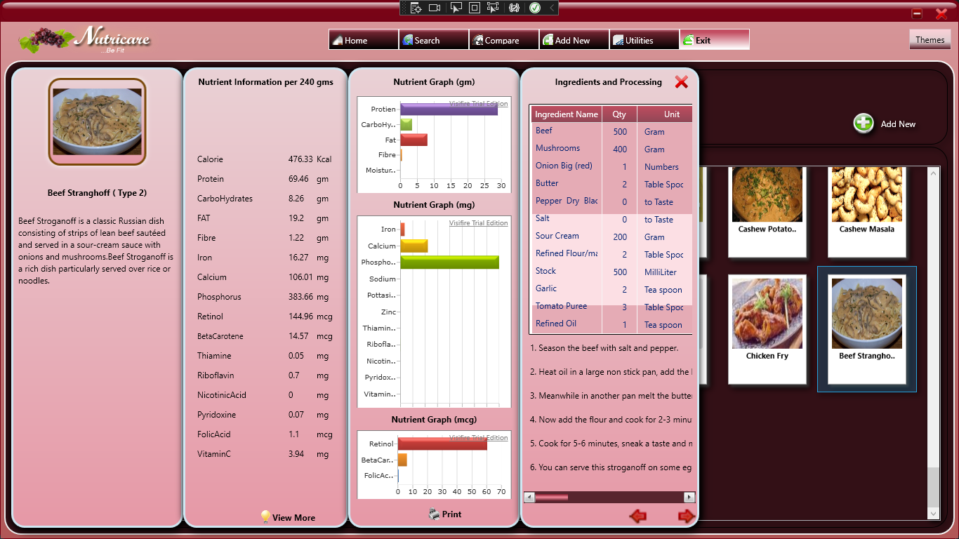

Nutrient Info per [StandardWeight] gms:

NutrientValue = (TotalNutrientValue / 100) * StandardWeight

The term ‘Nutrient’ refer to different nutrient such as Calorie , Protein , Fat ,Calcium ,etc..